About the data:
Dataset 1: My first data is called Adult dataset(UCI) which has 48790 sampes and 14 features. It is a binary classification problem with featues including education, occupation, gender and other demographical info with the result being if a person makes over 50K a year or not. I think its interesting to see if you can estimate the richness of a person based on demographics and very little other information!

Dataset 2: This is a dataset from kaggle that divides the people in 4 different groups based on the fitness levels. Features are mostly numerical including blood pressure, sit up counts, age etc. We have 13392 samples with 12 features. Is it possible to see if someone is ‘fit’ based on features like ‘body_fat%? What does fitness depend on? We have four grades or ‘goodness levels’ with ‘A’ being the most fit.

Why interesting? Because they are different in many ways. Other than being of completely different topics, dataset 1 has mostly categorical features while dataset 2 had mostly numerical features. Dataset 1 is binary classification where as Dataset 2 has 4 classes. Dataset 1 also has more outliers as compared to dataset 2. I anticipate different performances by different models. The maximum accuracy achieved by dataset 1 is 88.7% [https://rpubs.com/H_Zhu/235617] and for dataset 2, its 76%(kaggle). This is the reason I will be considering DS 2 a harder classification problem and assume the model will require more complexity for this data. There is also more inter-feature correlation in dataset 2 as compared to dataset 1. DS1 has no correlation coeff between features greater or equal to 5 but DS2 has about 5 features with higher than 0.5 correlation coefficients with each other.

Strategy:
Dataset 1 is imbalanced and Dataset 2 is balanced. I am using imblearn to undersample majority class for dataset 1 to have a balanced dataset. There are no missing values in dataset 2 and for dataset 1, I am using most frequent values for imputation. Then, I am doing a 70-30 split for training and testing datasets. Because both sets are balanced and we are not particular about any true positive or true negative rate more than the other, I am using accuracy as a scoring metric. I am using all the scikit-Learn methods for this assignment. Most of the methods I use for tuning use cross validation, but if the don’t, I am “borrowing” part of the training set for my hyperparameter tuning. I have called dataset 1 as “census pay” and dataset 2 as “body performance”. My tuning plan for the models is to find the first parameter, freeze it and find the second best parameter. Then freezing second, see if first parameter can be improved.

Summary table
Classifiers | Data sets | Training accuracy | Testing accuracy | Training time (s) | Testing time (s)
Decision Trees (unconstrained) | DS-1 | 0.9998 | 0.756741 | 0.1023 | 0.0035
Decision Trees (unconstrained) | DS-2 | 1.0 | 0.642857 | 0.0711 | 0.002
Decision Trees (post pruned) | DS-1 | 0.8362991 | 0.81595 | 0.1162 | 0.0051
Decision Trees (post pruned) | DS-2 | 0.777789 | 0.689646 | 0.1116 | 0.0024
Knn (uncons) | DS-1 | 0.8181 | 0.789841 | 0.0038 | 2.2254
Knn (uncons) | DS-2 | 0.7163430 | 0.596067 | 0.0119 | 0.3997
Knn (all features) | DS-1 | 0.818137 | 0.78984 | 0.0403 | 2.1767
Knn (all features) | DS-2 | 1.0 | 0.6331 | 0.0142 | 0.473
Knn(feature manipulated) | DS-1 | 0.9998776 | 0.78684 | 0.0364 | 2.3428
Knn(feature manipulated) | DS-2 | 1.0 | 0.63315 | 0.0129 | 0.4716
Neural Networks | DS-1 | 0.8287164 | 0.816 | 9.666 | 0.0039
Neural Networks | DS-2 | 0.7525069 | 0.744 | 10.1657 | 0.0038
SVM (linear) | DS-1 | 0.7728857 | 0.75945213 | 11.0938 | 1.772
SVM (linear) | DS-2 | 0.62363985 | 0.62518666 | 5.0739 | 0.8917
SVM(rbf) | DS-1 | 0.82107258 | 0.8123840 | 10.5727 | 5.0736
SVM(rbf) | DS-2 | 0.7535737 | 0.7125435 | 4.1595 | 1.9073
Adaboost  (unconst) | DS-1 | 0.82614810 | 0.82336 | 0.5232 | 0.0493
Adaboost  (unconst) | DS-2 | 0.608491 | 0.601294 | 0.4085 | 0.0513
Adaboost (constr) | DS-1 | 0.846389 | 0.83022 | 0.7038 | 0.0492
Adaboost (constr) | DS-2 | 0.676125 | 0.66351 | 0.2157 | 0.0122

DECISION TREES:
As a first step, I started growing decision trees with no bounds and got a testing accuracy of 75.6% on DS1 and 62.8% on DS2. However, the tree was huge with following properties:
DS-1 | max_depth | Total_nodes |  | DS-2 | max_depth | Total_nodes
DS-1 | 39 | 5831 |  | DS-2 | 26 | 3941

Prepruning:
For prepruning, the two variables I decided to look into were max_depth and min_samples_split. The process is simple: First I find optimal depth and using that, I find the best value for min_samples_split.
Dataset 1:
Following validation charts show the rationale for using max depth of 6 and min_samples_split = 2. Prepruning reduced the nodes in this classifier from 5831 to 93!
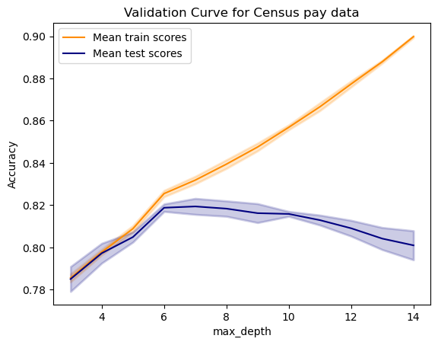
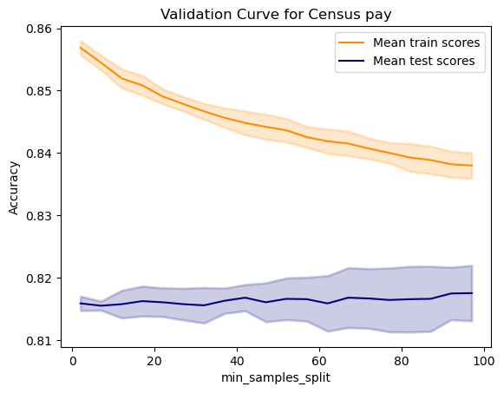
Accuracy/times as follows:

Decision Trees (Prepruned)
Dataset: DS-1
Training Acc | 0.81722
Testing Acc | 0.8088
Train time | 0.0548
Test time | 0.0037

Dataset2:
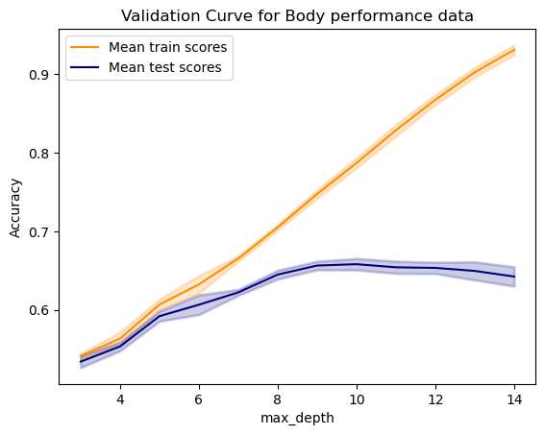
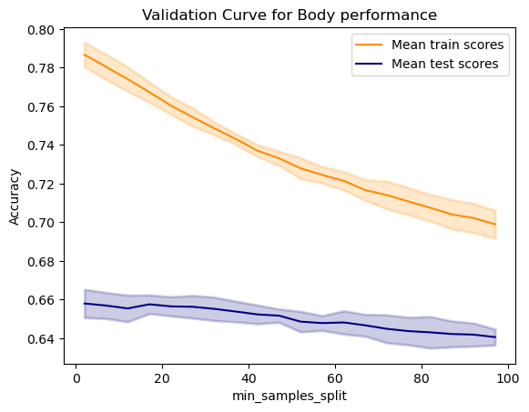
Using similar process, the selected max_depth and min_samples_split were selected from the plots below. The new classifier reduced total nodes from 3941 to 421 and has the following properties:
Max depth =10; min_samples_split=2
Dataset: DS-2
Training Acc | 0.72775
Testing Acc | 0.67695
Train time | 0.0611
Test time  Prepruning analysis:  Maximum depth required for optimal performance for ds1 is more than ds2. This implies the difficult nature of separation for ds2 as it needs a more compelx model to achieve the best accuarcy. | 0.0019

Prepruning analysis:
We can see from the max_depth charts that for bigger values of max_depth, we start to see over fitting. The validation and training accuracies start to diverge at max_depth=6 for DS1 and max_depth=8 for DS2. Why does it happen? Because as we keep increasing depth, the tree starts to capture unimportant patterns in the data by using features that are not related at all or making splits that are too specific to the training data. For DS1, we can see the tree using more of fnlwgt feature which is not that important or relevant.
The min_samples_split defines minumum samples that need to be in a node for it to further split into further nodes. We see a similar behaviour for min_samples_split with max_depth fixed. However, the direction is opposite. The smaller the value of min_samples_split, more the difference in the training and testing accuracies i.e. overfitting when min_samples_split is smaller. Reason is simple; if the value is more, we have to wait for more samples to accumulate in a node before we can split. But smaller the value, we can keep splitting to even capture the noise in the data. For both sets, there is no advantage to having a bigger minimum number of samples per node before splitting. This trend is also confirmed when we look at the learning curves for DS-1, where the variance is more when min_samples_split =2. This difference would be more pronounced if we do not bind the classifier with max_depth. The testing accuracy is somewhat similar for both datasets.
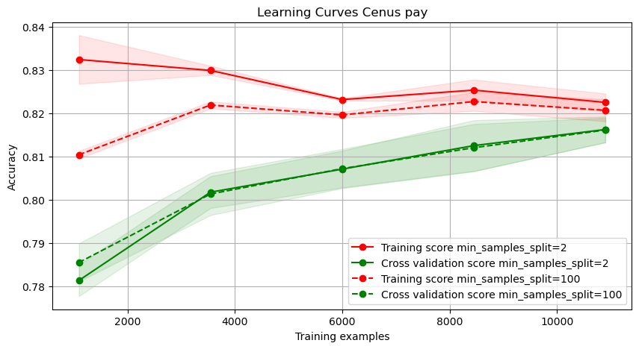Illustration 1: Learning curves: showing effect of min_samples_split for DS-2
Maximum depth required for optimal performance for DS1 is more than DS2. This implies the difficult nature of separation for DS2 as it needs a more compelx model to achieve the best accuarcy.

Cost complexity pruning or Post pruning:
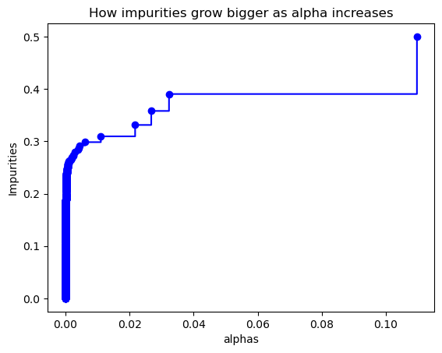
Post pruning works by cutting away the branches it deems are the weekest (do not contribute to a better accuracy). For this type of pruning, I am using training and validation test. As alpha increases, the number of leaves decrease, which means more mixed samples in each leaf which results in a higher impurity (chart for DS1 shown to the left).
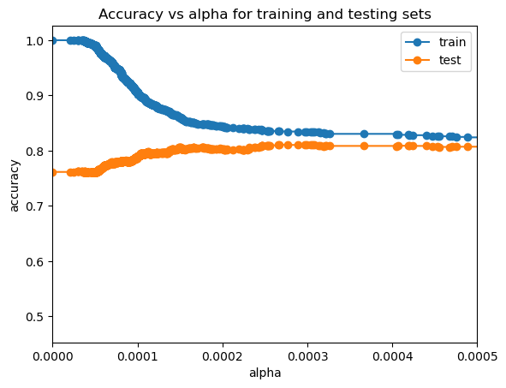Illustration 2: alpha vs accuracy for DS1

Dataset 1 & Dataset 2:
From Illustration 2 on the right for DS1, best accuracy is achieved at alpha= 0.00025. At this value of alpha, the resulting tree has following properties:
Max depth=13, Nodes = 165 =, ccp_alpha=0.00025, min_samples_split=2

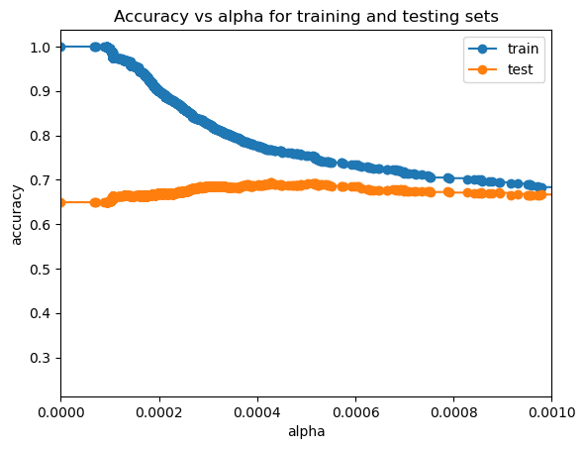Illustration 3: alpha vs accuracy for DS2

After looking at Illustration 3, the best alpha = 0.0005 and resulting classifier has properties:
Max depth 13, Number of nodes = 497, ccp_alpha=0.0005

Analysis on postpruning:
Post pruning results in the same depth for the trees for both datasets but number of nodes are very different. Because of difficulty of classification for dataset 2, we have more than twice the number of nodes for this classifier as compared to DS1. Looking at Illustration 2 and Illustration 3, we see that at lower values of alpha, we see that the trees resulting from those values are over fitting the data. As alpha increases, the accuarcies converge for both datasets, resulting in the best alpha value. Lower alpha cause overfitting because it lets the trees go as big as possible by not penalizing bigger trees.
One other thing I noticed after looking at the decision trees (pruned and unpruned) were that some features were very rarely used in the pruned trees that were abundantly used in post pruned. For example, for DS1, feature ‘fnlwgt’ (final weight) was used only once in the pruned trees where as it was used atleast 7 times in umpruned ones. This, I believe, is an indication of what a good feature is in terms of generalization and which is not. Some features like relationship, hours-per-week and education-num were used as top features for splitting for all trees, which indicate their importance for classification. Prepruning and post pruning produced almost identical results in terms of accuracy for both datasets.

Final Learning curves(Postpruned):
Dataset 1:
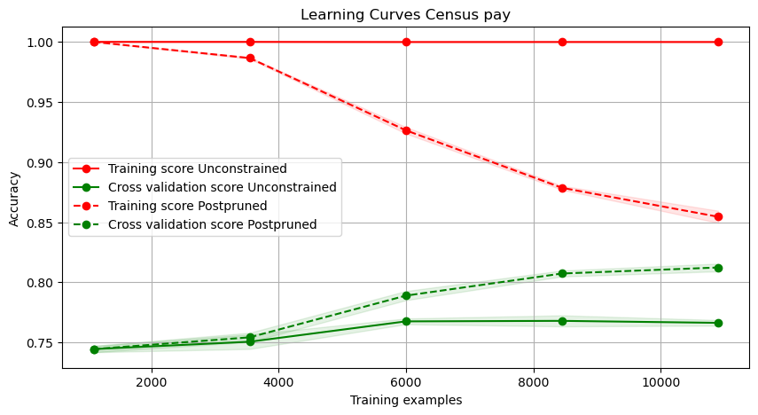
The learning curves on the left are that of an unconstrained tree and a post pruned tree. For the case of unconstrained one, we can see the high variance as its overfitting the data with high training accuracy but a very low validation accuracy. It also shows no improvement in generalization after 6000 samples.
The postpruned tree’s learning curve shows good learning progress as it receives more data, however the chart does show that the tree can benefit from more data. This data can be in terms of more samples or some extra features. The slopes show that learning is still ongoing and have not plateaued.

Dataset 2:
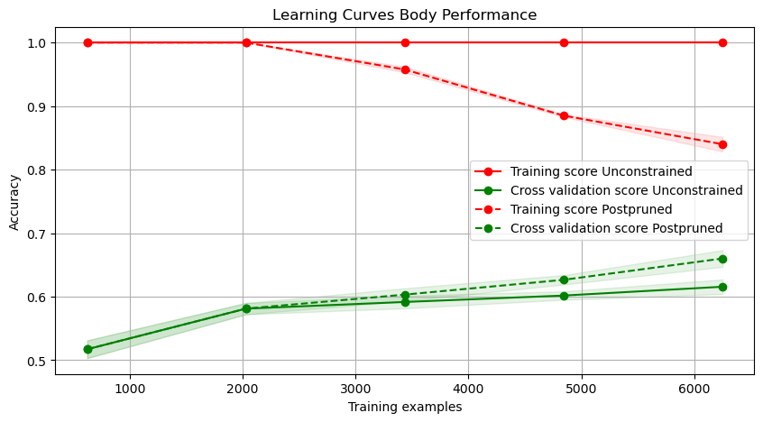
Post pruned trees for DS-2 also performs better in terms of bias and variance as compared to unconstrained trees. After 2000 samples, post pruned trees result in better validation accuracy than unconstrained ones and the training and testing accuracies are moving closer. However this chart also shows that the decision tree can benefit from more data as the curves have not yet reached a plateau. This data can be in terms of more samples or features. In the learning curves, we can see the high variance for both the curves, with it getting better for the pruned trees with more samples. There is insignificant effect on the unconstrained trees.

k Nearest Neighbors:
The approach to the problem was similar to decision trees. I first started by modeling without any constraints and then looked into improving that. My hope was that knn will perform better on DS2 as compared to DS 1 because DS1 had a lot of categorical values and DS2 was primarily a numerical column data. Data is used after standardizing and label encoding the categorical data.

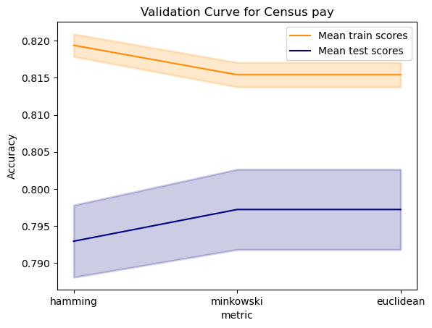
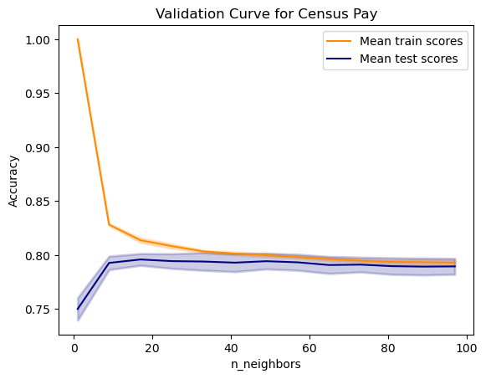
The two metrics I wanted to test were n_neighbors and the type of distance metric using validation curves. The best attributes of the classifiers were:
Dataset 1:
- metric='minkowski’, p=2
- n_neighbors=15
- weights='uniform'
Testing accuracy=78.98%.
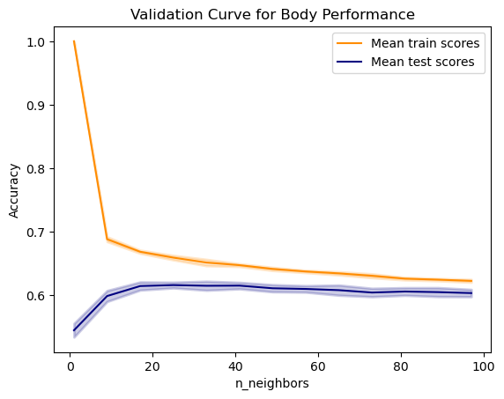
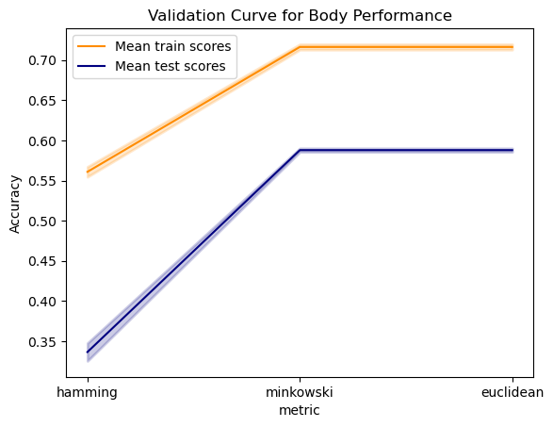
Dataset 2:
-metric='minkowski', p=2
- n_neighbors=25
- weights='distance'
Testing accuracy=63.31%
Analysis of value of hyperparameters:
Looking at the validation charts for n_neighbors vs accuracy, we can see that k=1 leads to overfitting for both datasets where training accuracy is high but testing accuracy is low. A higher k leads to a more smoother decision boundary and reduces overfitting. However, if k gets super high, it may lead to an oversimple model, unable to capture intricacies of the data and underfit. The values for k for the datasets seem a good compromise.
For metric, euclidean and minkowski produced equivalent results. Minkowski is a general case of both manhattan and euclidean distance depending on the value of ‘p’. In our case, p=2, meaning euclidean distance. I do not think that this is a good distance metric and that the optimal value that can be obtained from knn will be dependent on customised distance metric.
Analysis DT vs KNN:
My expectation that knn will perform better on datatset 2 than dataset 1 was debunked. Both the datasets performed worse than decision trees. So I looked at the biases prevalent in knn and upon investigation found the reasons to include Curse of dimensionality, all features were weighted equally and the most important, its not clear to knn how to define distance metric for catagorical variables and it will assign a difference of 1 between each of the categories. So, I started messing around by giving more weights to certain features before passing the data through KNN. My findings were as follows:
dataset 1:
To battle curse of dimensionality, I chose 8 out of 14 columns that I believe were most important (domain knowledge!). These columns were 'age', 'sex', 'occupation', 'education-num', 'relationship', 'capital-gain', 'capital-loss', 'hours-per-week. Then using, some empirical testing, start fiddling with the weights of each feature and found that upscaling or downscaling a feature (‘age’ from 1 to 0.7 and relationship to 4 times the weight) increased my accuracy from improved from 78.6% to 81.951.
dataset 2:
Similar as dataset 1, I first selected 8/11 columns that I deemed relevant. Then I tweaked the weights of the features before applying knn on it. Upscaling/downscaling some features improved the testing score from 63.3% to 71.38%
Learning Curves
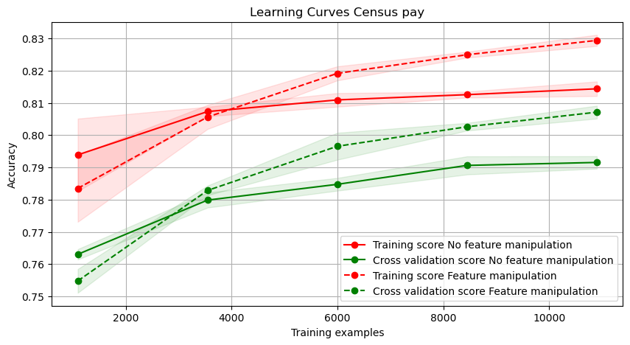
For DS1, we see two sets of curves on the left chart. Dotted lines are one with feature manipulation and solid lines are ones without feature manipulation. Without any feature manipulation, we can see that both training and testing accuracies are below the ones in which we have manipulated the features.
There is a slight variance as shown by the difference between the curves for both models.
This chart also shows that the model that is dealing with manipulated features continues to learn while the other model has sort of plateaued and no more data will help it. The small consistent gap between the curves of a similar model also hints at some ‘umodeled influences’ in the data.

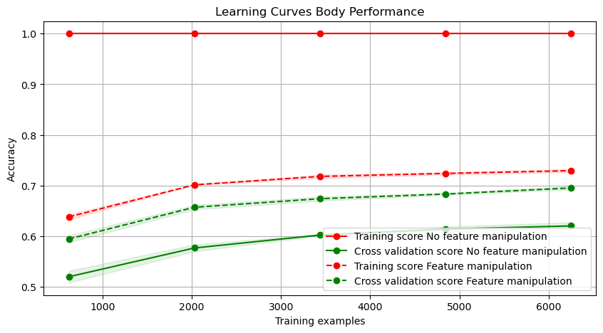
On the right are the learning curves for DS2 showing solid lines for no feature manipulated model and dotted for the model where we have manipulated the features. Because of the weights as ‘distance’ for the ‘no feature manipulation’ model, the training accuracy is a 100 as the training samples are on top of each other, making the closest sample to the traing data itself. Inverse of distance becomes infinity and thus training data gets all right answers.
There is a high variance in the no-feature-manipulation model and there seems to be very little variance for the model dealing with feature manipulation. The validation accuracy after feature manipulation is better than before and the accuracy improves as data increases. However, with feature manipulation, as the data increases, both training and testing accuracies improve and the distance between the two seems to be closing in, meaning variance is decreasing. The small consistent gap also makes me think that there maybe ‘umodeled influences’ in the data that does not let us get the full picture.

Neural networks:
My first thought was to figure out a way to test emperically how many layers we need, followed by the number of neurons in each layer. I tested from 4 to 1 layers with varying no. of neurons/layer to find the one that produced best results. After layers/neurons, I am looking at which activation method to choose.
Dataset1:
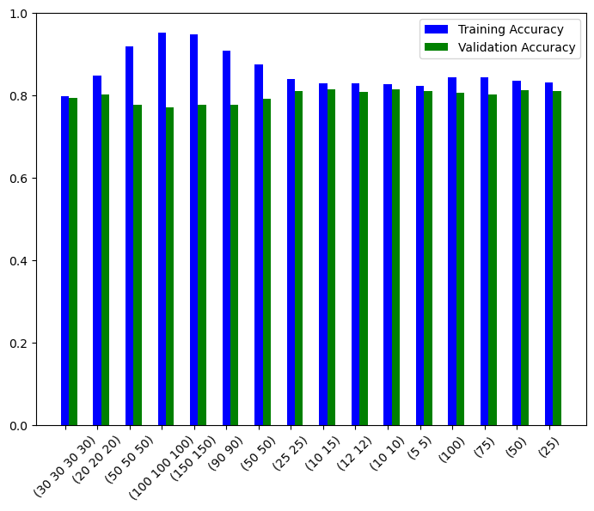
From the chart on the right side, I chose the one with maximum validation results i.e. 2 layers with 10 and 15 neurons. Models with more than 40 neurons/layer and more than 1 layer show overfitting. 2 layers with 10-15 neurons/layer performs well and does not overfit. We will see this in the analysis below as well where the network does not overfit, despite the number of iterations.

Activation functions were tested (Illustration 5) where ‘relu’ and ‘logistic’ gave best performance. ‘identity’ is too simple to capture the patterns in the data (as its linear), so we can see high bias for identity activation function (low train and validation accuracy). Sigmoid and relu both performed best but sigmoid can have slow convergence especially with a smaller learning rate. Tanh is similar to accuracy as relu but I choose relu because it took only 9 seconds to fit whereas tanh took around 20 seconds!
Illustration 4 shows the loss curves with the three activation functions. Logistic converged early but with a bigger error. Tanh and relu had good loss curves but relu converged earlier. The blue curve in Illustration 4 shows the final loss curve for DS 2.
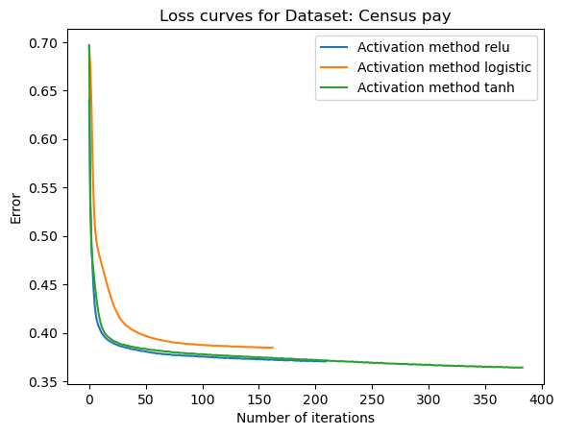Illustration 4: Loss curve for different activation functions for DS 1
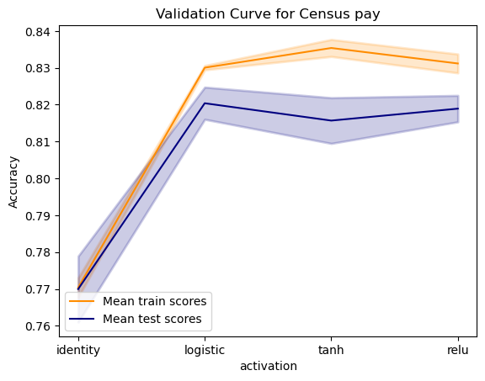Illustration 5: activation functions vs accuracy for DS1

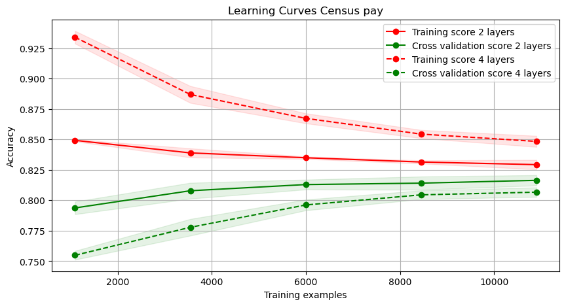
Learning curves
The chart on the right shows learning curves for the 2-layers network which is my final model (solid lines). It also shows curves for the 4 layer network for comparison purposes. The final model shows low variance and good accuracy. As compared to the final curves, the dotted lines (4 layers) have a relatively high variance and even though the training data performs better with more layers, validation accuracy decreases, showing less than optimal generalization.
This trend was seen through out that increasing layers or neurons per layer always resulted in overfitting; better training accuracy but lower validation accuracy.
Given more data, I think the training and validation curves will eventually touch each other, so more data (features and samples) maybe helpful.

Dataset 2 : Body Performance
For DS2, can see from the Illustration 6 below that for hidden layers with high number of neurons or for many layers, the training accuracy is very high compared to validation accuracy. This is the area of overfitting. We selected the model with least overfitting with least variance between validation and training accuracy as well as the best validation accuracy. Final model hidden_layer_sizes =(10, 10))
We can see in Illustration 7 that ‘relu’, ‘logistic’ and ‘tanh’ all produce similar accuracy. We see that identity is showing high bias with low train/validaiton accuracy. Identity is high bias because it is essentially a linear combination of features and has no nonlinearity which makes it too simple for the data.
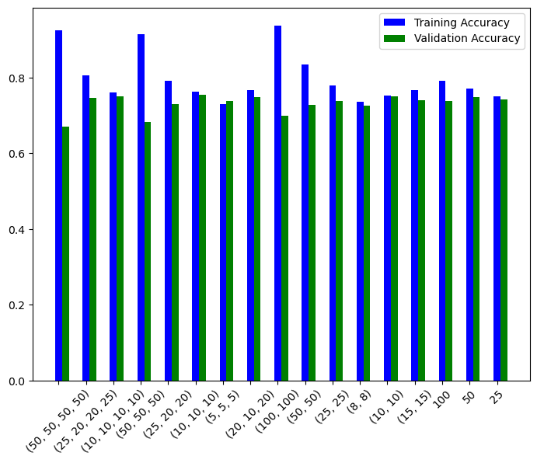Illustration 6: hidden layers vs accuracy for DS2
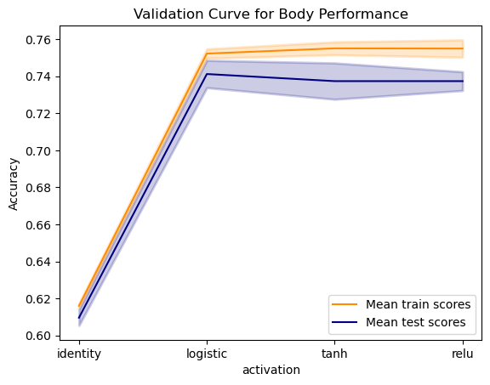Illustration 7: validation chart for activation functions for DS2
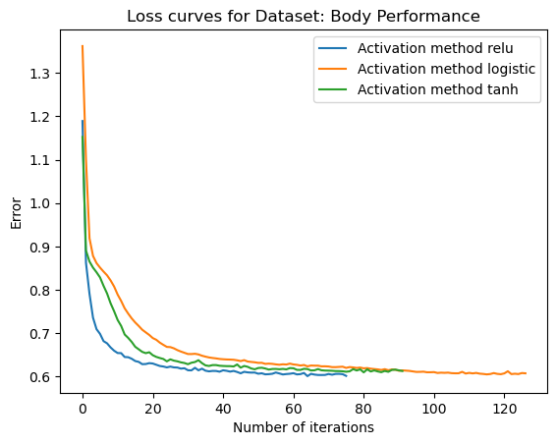Illustration 8: activation functions and error for DS2

In Illustration 8 above, we can see that all three losses are comparable in terms of loss. I am selecting ‘relu’ here again because its fastest (2 times faster than tanh and 3 times faster than logistic) and produces the smoothest loss curve. Curves also show a slight horizontal patch around 10-20 iterations for logistic and tanh. I believe the gradient of the loss surface is very low at this point and tanh and logistic gets slow with their weight updates. Relu has a big constant gradient in positive direction and keeps the weights changing and learning happens faster thna other activation functions.
The blue curve in Illustration 8 also shows the final loss curve for DS 2. It shows how the error reaches optimal value in less than 50 iterations.

Learning curve:
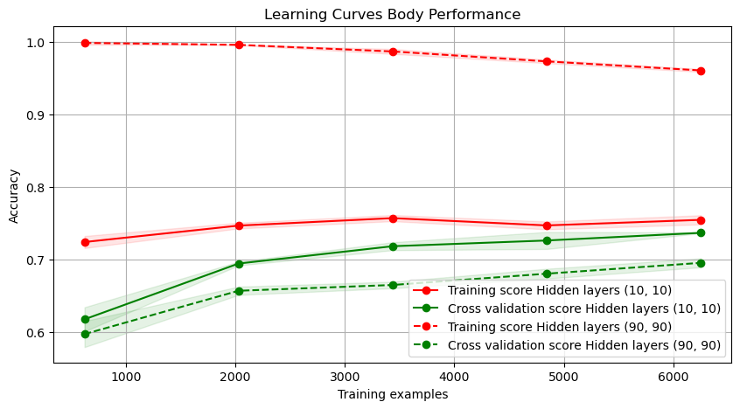

The solid lines on the left represent the final learning curves for dataset 2. The curves shows no bias and very little variance. Dotted lines, showing the curves for a 2 layer but many neurons network, show a very high variance in the model. I have observed that more neurons per layer cause much more overfitting than smaller number of neurons in more layers.

Analysis:
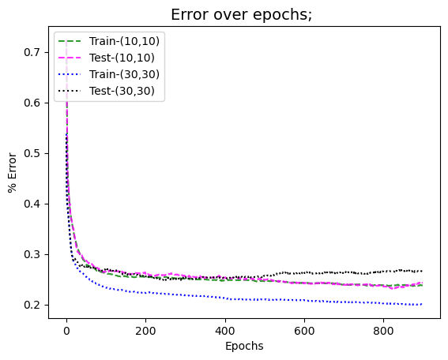Illustration 9: iterations and loss to see overfitting
Does number of iterations cause overfitting? To answer this, I calculated loss for my network (model with (10,10) hidden layers) but no matter how many iterations I ran, I did not see any overfitting. There was no room for it. However, when I increased number of neurons in each layer from 10,10 to 30,30 and ran the analysis again, I could see the model overfitting after iterations. This is shown in the Illustration 9 where green and pink dashed lines stay on top of each other whereas the curves for model 2 (30,30) start diverging after about 25 iterations.
This proves that number of iterations in a neural network can cause overfitting if there are more than enough neurons and/or layers

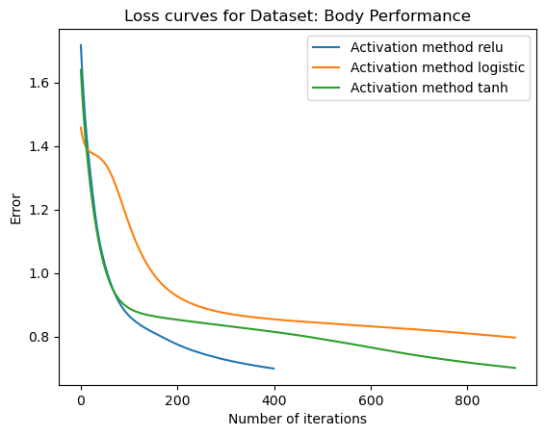Illustration 10: activation functions and loss at learning_rate =0.0001

Another trend I found interesting is the interplay between learning rate and type of validation used. For low learning rates, the convergence for logistic becomes slow and the learning becomes slow. It makes sense because the gradient of sigmoid is multiplied by learning rate and the gradient of sigmoid is very small.
Using tanh has a better gradient than sigmoid but its too slow and still gradient is smaller than relu when the input value is large or small (tanh gradient becomes 0 as the values on the x-axis moves toward the extremes). Relu is the smoothest and fastest converging to the final error at lower learning rates. This trend is shown in Illustration 10 where learning rate used is 0.0001

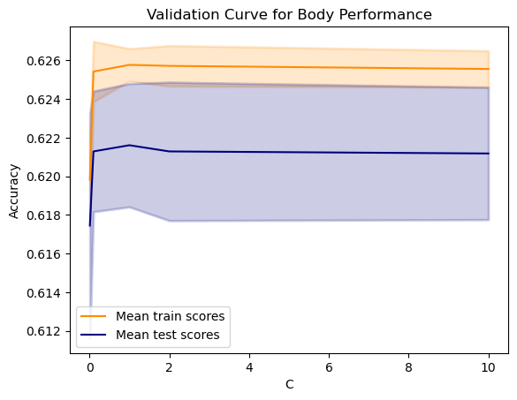
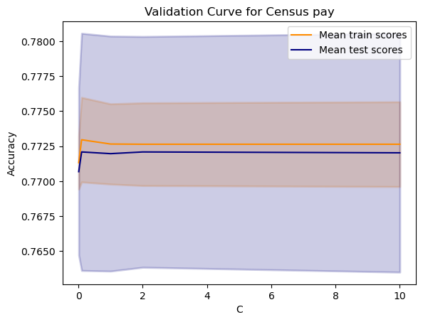
SVM (Linear)
Dataset 1 & Dataset 2:
I started with the linear kernel of the SVM which is really good for solving lienarly separable data without overfitting (or maximizing margin). I used validation curves to see if C mattered a lot for linear classifier. As shown in the charts to the right, it does not make much of a difference what penalty we put on misclassifying data for linear SVM.

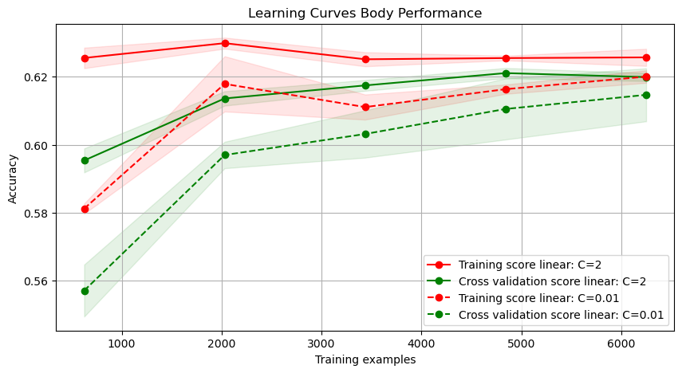
Learning curve for different Cs
Because the data is not linearly separable, I expected to see underfitting or high bias in the learning curves for the linear kernel. Because the highest accuracy received so far for dataset 2 is 73%, an accuracy of 60% is indeed showing high bias.
Another trend to notice is that smaller C leads to lesser accuarcy because we dont care much about accuracy but more about the margin.

RBF kernel:
Dataset1 & Dataset 2:
rbf kernel are pretty cool with their ‘kernel trick’ where they are able to see high dimensional relationship between data (without transforming them in high deimnsions) to be able to give us complex decision boundaries based on data relationship in possibly infinite dimension. Using validation curves, I find the best values for C and gamma, both of which define the shape of the decision boundary. Where a smaller C means more margin between classes, a smaller gamma means simpler as contrast to complex boundaries. The effect of C was not noticeable as much in the liner kernel case because its not easy to overfit when considering linear decision boundaries. However, in the rbf case, we can see that overfitting occurs around C >2 as we start penalizing wrong classifications more, it starts to make tighter and tighter boundary so as to not misclassify. We can also see area of overfitting with gamma > 0.06 with similar reason that a higher gamma can make the boundaries more ‘curvy’ around data points in order to receive better accuracy.
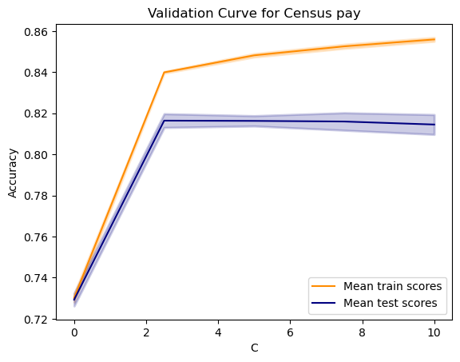
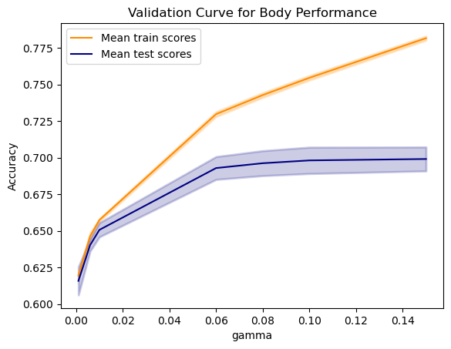
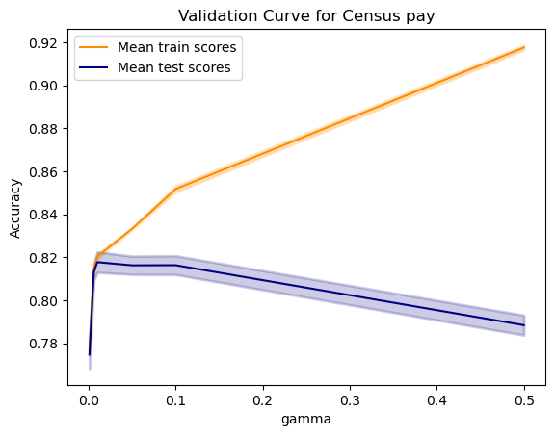
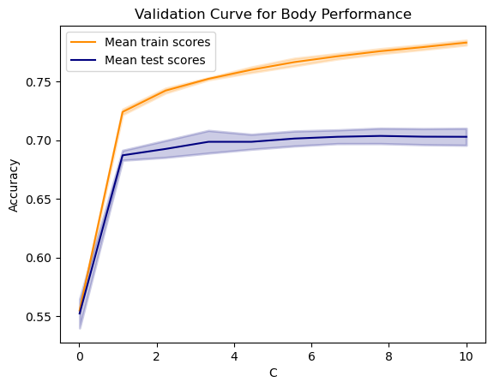

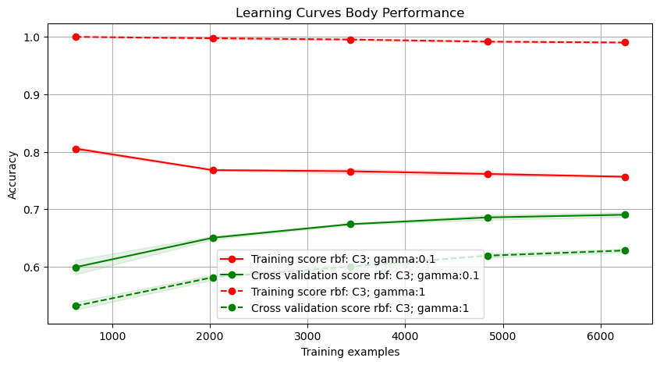

Relationship between higher values of gamma and overfitting can be seen in the learning curves on the right. Dotted lines with a higher gamma value have a very high variance. It is performing excellent on the training data but performing poorly on the test data. On the contrary, a smaller gamma is able to generalize better.

Learning Curves for Linear and RBF kernel:
The left chart below shows the learning curves for linear and rbf kernels for dataset 1 and chart on the right shows learning curves for linear/rbf kernels for dataset 2. rbf kernels show higher training and testing accuracy on both the datasets even though they exhibit slight variance. The solid lines for linear kernels shows high bias because of the linear kernel underfitting the data.
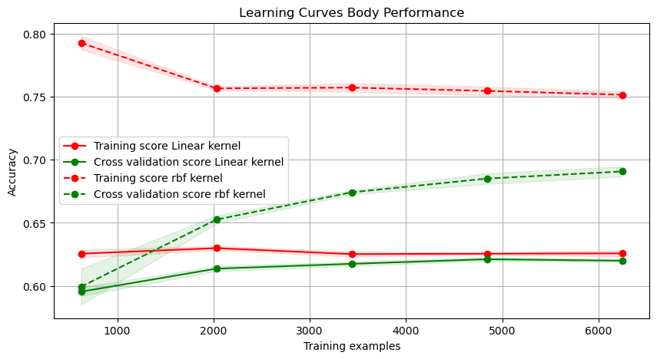
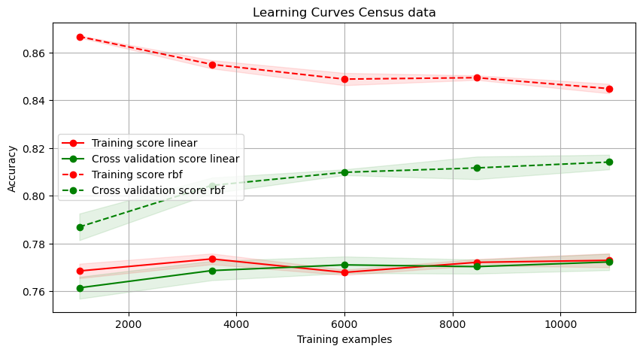

Adaboost:
For adaboost, I started by using the classifier’s default settings and testing on the datasets. The default classifier has learning rate of 1, 50 estimators and decision tree stumps as base estimator. The classifier performed similarly on scaled and unscaled data.

DS1: Training Acc 82.61%, Testing Acc. 82.33%; DS2: Training Acc 60.84%, Testing Acc. 60.129%

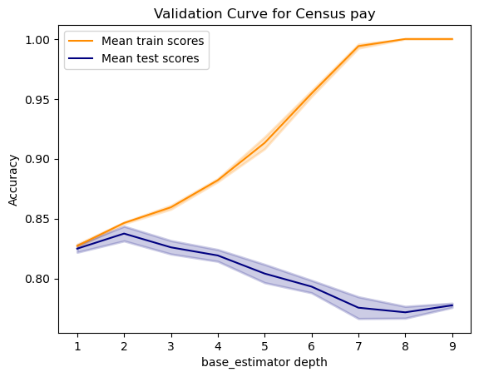
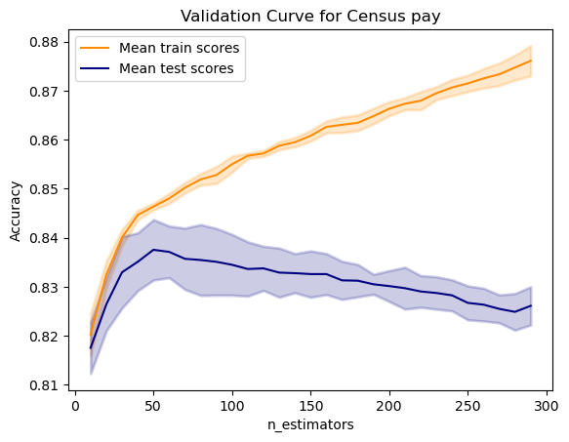
Tuning:
For tuning, I am looking into max_depth of the base estimator and number of estimators in the ensemble.
Dataset 1:
For dataset1, I had a good accuracy to begin with. I looked into the validation charts for these parameters to look for a more favorable combination. My final classifier had following characteristics:
base_estimator_depth =2, n_estimators=50
We can see from the validation charts above that as the base_estimaror depth increases, the model starts overfitting. The only way adaboost can overfit is if the underlying estimators start to overfit which we can see after the base estimator’s depth increases more than 2. After tweaking, testing accuracy improved by 1% and training time improved by 10 times.
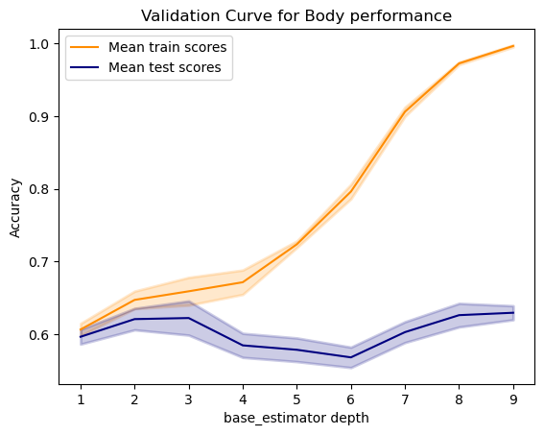
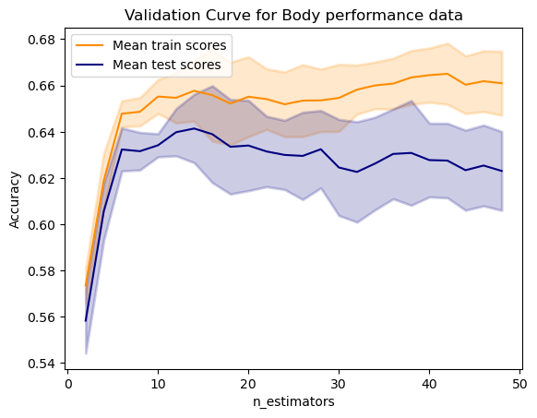
Dataset 2:
Similar process was used as dataset 1 to find optimal params for the classifier. However, interestingly, n_estimators were very few compared to DS1. I believe it is because the dataset 2 does not have many outliers that need to be tweaked by subsequent classifiers. The optimal depth of the trees was 1 more than for DS1. I believe it to be the more complicated nature of dataset 2. Final classifier had the properties: base_estimator_depth =3, n_estimators=12.
After tweaking params, testing accuracy increased by 6.3%!

Learning Curves:
For dataset 1 and dataset 2, tuning improved the variance as well as the accuracy of the model.
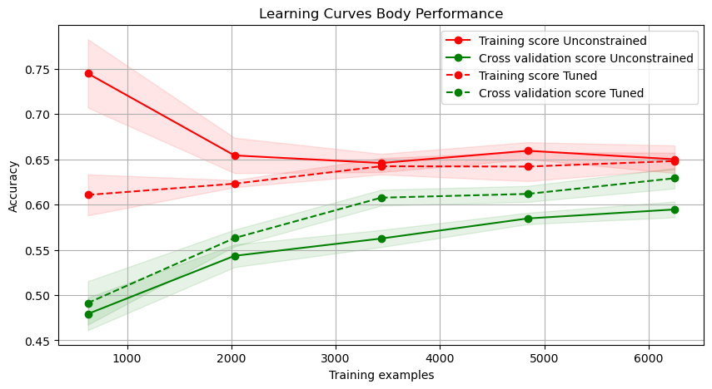
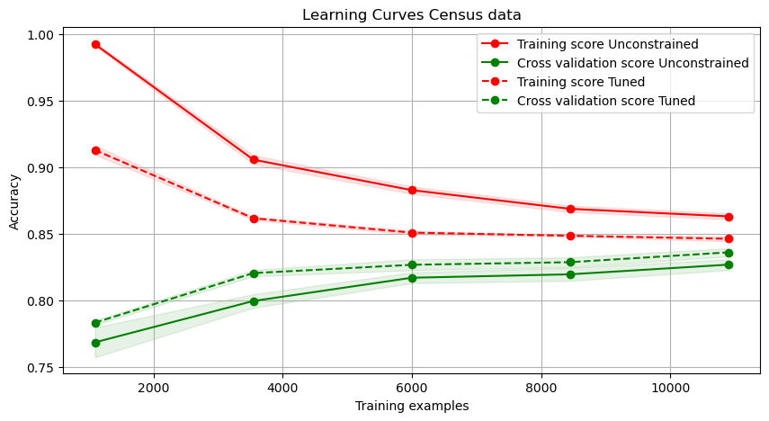

Timing Analysis:
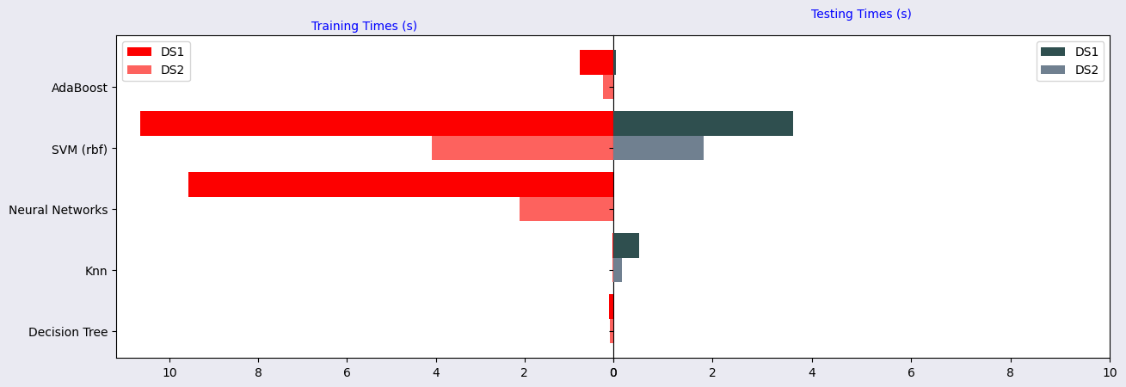
From looking at the wall clock times for training and testing, some observations are as follows:
For all the models, we see that dataset 1 takes more time than dataset 2. This is probably because dataset 1 is bigger (3x) than dataset 2.
Decision Trees take more time training than testing. This is because they are eager learners, trying to learn everything from the data before seeing the test data. This makes the training time longer, but testing time slower, as test data just has to traverse one branch of the tree and will have to read a maximum of log(depth) nodes.
KNN is a lazy learner because they do nothing but save them in some storage and will consult the data when needed. So their training time is pretty low but that is offset by a high testing time. This is the only learner with a higher testing than training time
Neural networks also fall in the eager learner category as they try to learn the weights before encountering the test data. They learn all they need to learn from the training data. They were one of the slowest in training among all the machine learning algorithms but also produced the reasonably good accuracy with very little effort.
SVM’s superpower is in the ‘kernels’ and ‘kernel tricks’. These kernels are able to see different relationships between data andcthe type affects the training and testing times for the datasets. They are lazy and eager at the same time in a way that they want to learn from the data but only consider a few of the training points to decide on the decision boundary (support vectors). It is also one of the slowest algorithms as it took a long time to train and test the data. Interestingly enough, they also take time predicting on the data.
Adaboost has a longer training time compared to testing time. Reason is that it trains several weak learners (decision trees in my case) one after the other, calculating and adjusting weights on the data in each iteration. For testing, it just has to get an answer from each of the trees and vote in case of classification.

Comparison of all Models:
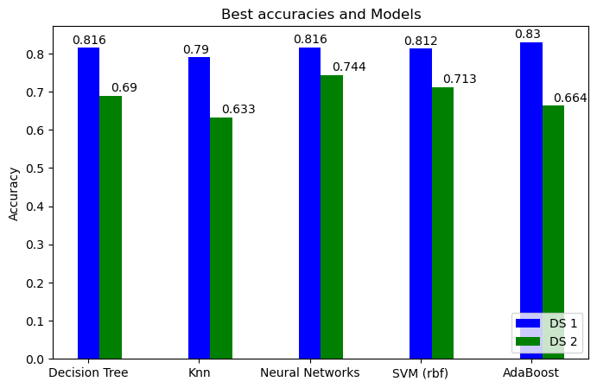

Most of the models performed very similar when tweaked. I am going to base my comparison on time taken and accuracy achieved. Some observations are:
- Decision trees were the easiest to work with as they required no preprocessing and they were very fast. They are very transparent as well in showing us which features were important and how were they divided. The accuracy achieved was very comparable to other models. However it is very important to do pruning as decision trees will overfit, if left untouched. Post pruning and pre pruning both worked well for the datasets.
- Knn performed worst among all the models for both the datasets. When tweaked, the model performed similarly but a big takeaway is that to make knn better, domain knowledge is very important to make a good distance metric! The preference bias (mentioned in the report in the knn section) really hampers a good performance.
- AdaBoost performed better than all models on DS1. Their learning curves for DS1 showed very little variance (compared to decision trees) and no bias. Adaboost did not perform as well on dataset 2, perfroming even worse than decision trees. Looking into the confusion matrix for dataset 2, I saw that decision trees were better for all four classes as compared to adaboost. A couple of things I looked into was if adaboost was overfitting. It is not overfitting compared to decision trees as they have similar variance. Then I looked into reducing number of outliers to see if the accuracy improved. Because of the exponential loss used in adaboost, it can be very sensetive to outliers. In order to truly understand outliers or bad data, we need domain knowledge which I do not have. I tried removing values that were above the 1.5xQ3quartile and below the 1.5xQ1 quartile for the most important columns. It did not improve the performance. In order to improve performance, I believe we can look into column values in light of the labels and find outliers using cook’s distance or similar. Then removing outliers can probably improve the performance of adaboost. Another possible hypothesis for not-as-good performance may be that adaboost does not perform as well on multiclass datasets as it does on binary datasets. This is based on a 2013 paper by Fleyeh, H., Davami, E. “Multiclass Adaboost Based on an Ensemble of Binary Adaboosts” in which the authors argue the case that adaboost is not as good for multiclass datasets as it is for binary.
- Neural networks are relatively easy to work with and have the potential to be great, but takes a little bit time. They received the highest accuracy for data set 2. A deep neural network can also act like a black box so its difficult to know what features they think are important or in what ways are the features combined to give a certain performance. However, in a shallow network, we can ‘guesstimate’ the importance of a certain input feature by looking at the weights.
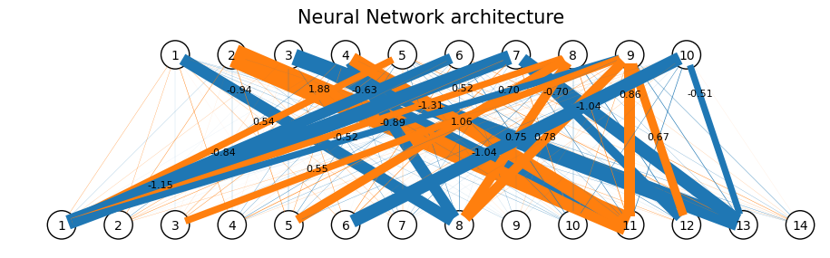
We can see that some features (bottom layer) have a higher weight and some doesn’t have significant weight. We can infer feature importance from that. However, after first layer, it gets more and more obscure how the different features are being connected and internally, what exactly is the combination it is trying to ‘see’.
One caveat is that it is very easy to be swept away and overfit the data. So, it is important to see loss curves to make sure we don’t run too many iterations and see performance compared with neurons/layers to avoid the same issue. All in all, I think the time taken and the preprocessing is worth getting a good accuracy and minimal variance.
- SVMs (rbf and linear) took too long and improvement in accuracy from them was not worth it. They also require scaling the data. Linear was not complex enough and rbf gave equivalent accuracy as decision tree and neural networks. For me, this model did not perform well enough in terms of time and accuracy.

Overall, Adaboost performed best for dataset 1 and neural networks performed best for dataset 2. I base this judgement on time consumption and aquired accuracy. Neural networks and adaboost did take time training (more than decision trees for example) but they were fast in prediction and good with accuracy.

References:
- https://scikit-learn.org/stable/auto_examples/model_selection/plot_learning_curve.html#sphx-glr-auto-examples-model-selection-plot-learning-curve-py
- https://scikit-learn.org/stable/auto_examples/model_selection/plot_validation_curve.html#sphx-glr-auto-examples-model-selection-plot-validation-curve-py
- https://www.researchgate.net/publication/228947999_Multi-class_AdaBoost
- https://stackoverflow.com/questions/31981453/why-estimator-weight-in-samme-r-adaboost-algorithm-is-set-to-1
- https://www.diva-portal.org/smash/get/diva2:643016/FULLTEXT01.pdf
- https://github.com/jzliu-100/visualize-neural-network

